**CSC3320 System Level Programming**

**Homework 5**

Due at 11:59 pm on 11. 25, 2019

**Part I:**

Continue the part in homework 4. A sample of the output is as below:

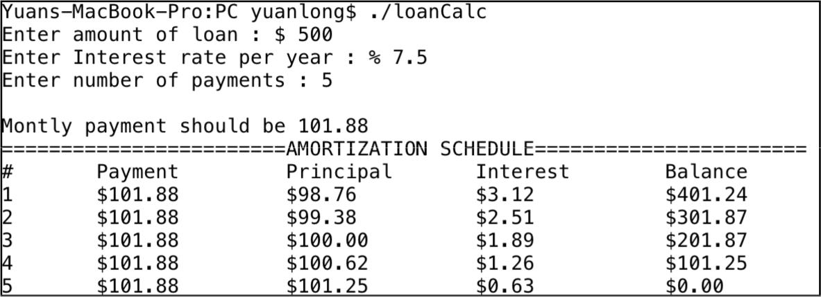

***Note****:*

* *To convert a string to a float point number, you can use the library function* ***atof***
* *The C program can be implemented within 80 lines of code. If your program is longer than 80 lines, you may need to think about how to simplify your program.*

***Question:***

Modify your C program by accepting **the three inputs from command line**. The first argument is the amount of loan, the second one is the interest rate per year and the last one is the number of payments. Name this C program as **loan.c**. To run the executable, e.g. you can try the command as below:

**./loan 500 7.5 5**



***Note****:*

* *In your answer sheet, for the C program above please attach a screenshot of the output when amount of loan is $2000, interest rate per year is %7.5 and number of payment is 6.*
* *Put the source code of each C program above into your answer sheet.*
* *Upload the c file of each C program above into the submission folder of iCollege.*

1

**Part II:**

The following structures are designed to store information about objects on a graphics screen. A **point** structure stores the x and y coordinates of a point on the screen. A **rect** structure stores the coordinates of the upper left and lower right corners of a rectangle.

struct point { int x, int y;};

struct rect { struct point upperLeft, lowerRight; };

1. Write functions that perform the following operations on a rect structure r passed as an argument:
   1. Compute the center of r, returning it as point value. *Function name:* ***Center***
   2. Move r by x units in the x direction and y units in the y direction, returning the modified version of r. (x and y are additional arguments to the function.) *Function name:* ***Move***
2. Suppose following declaration is in effect.

struct rect *p;

Assume that we want p point to a rect structure whose upper left corner is at *(9,8)* and whose lower right corner is *(2,1)*. Write a series of statement that allocates such a structure and initialize it as indicated.

3) Now modify **rect** structure by adding one more member in it as following:

struct rect

{ struct point upperLeft, lowerRight; char *name;

};

Assume that we want p point to a rect structure whose upper left corner is at *(9,8)*, whose lower right corner is *(2,1)* and name is “*MyRect*”. Write a series of statement that allocates such a structure and initialize it as indicated.

***Submssion of Part I and Part II:***

* Upload an electronic copy (MS word or pdf) of your answer sheet to the folder named “**HW5**” of the dropbox in the iCollege system
* Upload file ***loan.c*** to the folder named “**HW5**” of the dropbox in the iCollege system. Note: if you do not upload these C files, you would get zero for this assignment.

2

* Please add the homework number and your name at the top of your answer sheet.
* Name your file in the format of HW5_FirstnameLastname (eg. HW5_YuanLong.docx, HW5_YuanLong.pdf

3